EXERCISE-15

15.Design TM using simulator to accept the input string anbn

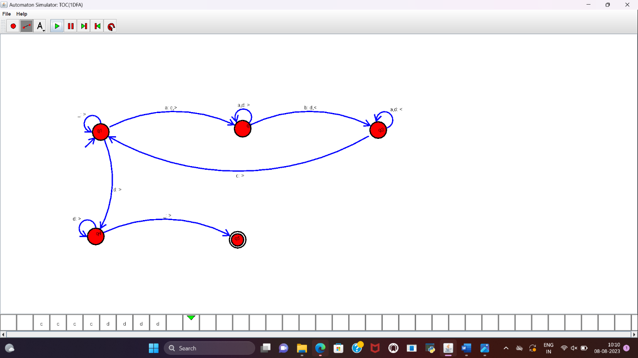

RESULT:

TM is designed to accept the string a^nb^n and implemented successfully.